**­­­­­**

**USER INTERFACE**

**DESIGN & DEVELOPMENTS**

**What The Fish**

www.fishingbuddy.com.sg

* Visual References
  + Snapshot of current www.fishingBuddy.com.sg website
  + CURRENT Website UI Styles
    - Call-To-Actions, Font Styles, Colour Palette
  + COMPETITOR Websites UI Styles
    - Typography
    - UI Look & Feel
* Layout Sketches
  + Proposed UI Revamp Solution, using Wireframes
    - Desktop view: Home page, Category page, Product details page, Cart page, Checkout page
    - Mobile view: Home page, Category page, Product details page, Cart page, Checkout page
* Screen Design & Developments
  + Proposed Solutions
    - UI Revamp description
    - Proposed new functionalities
  + Proposed UI Styling
    - Call-To-Actions, Font Styles, Colour Palette
  + UI Flow
* Icons & Graphical Developments
  + UI Components
    - Desktop Prototype website User usage flow, & Prototype pages
    - Mobile Prototype website User usage flow, & Prototype pages
    - Components of the website: Buttons, Icons, Form fields

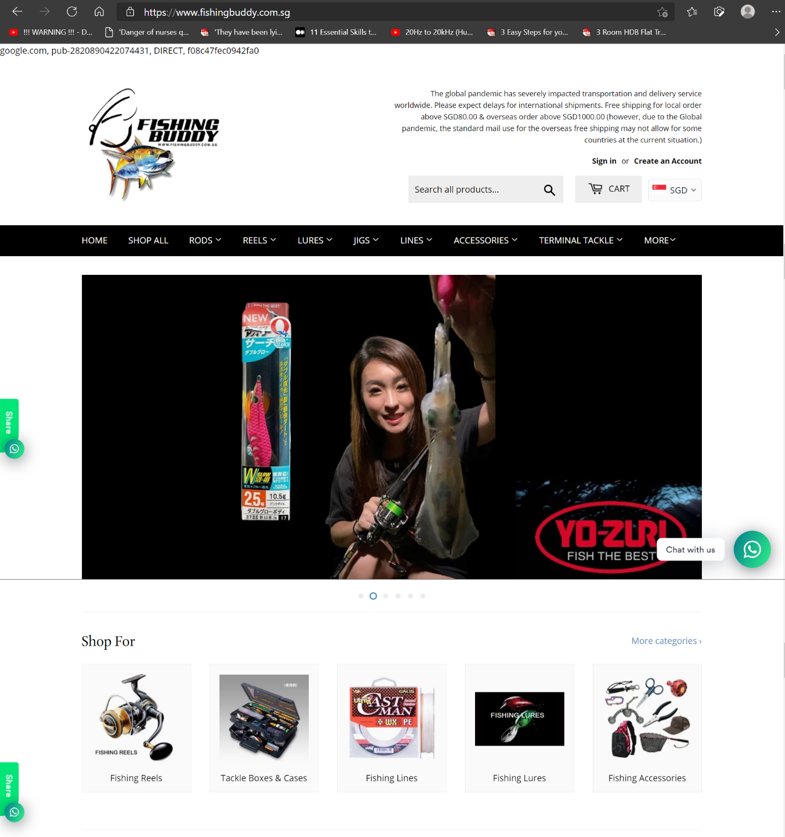

Current Website:

[www.fishingbuddy.com.sg](http://www.fishingbuddy.com.sg)

* Google text at top unnecessary to user.
* Overly large header section.
* Covid pandemic note can be reduced to a button.
* Overly large carousel banner, can be reduced to include more products display in the viewport.
* Product category pictures can be smaller to present more categories in one glance.

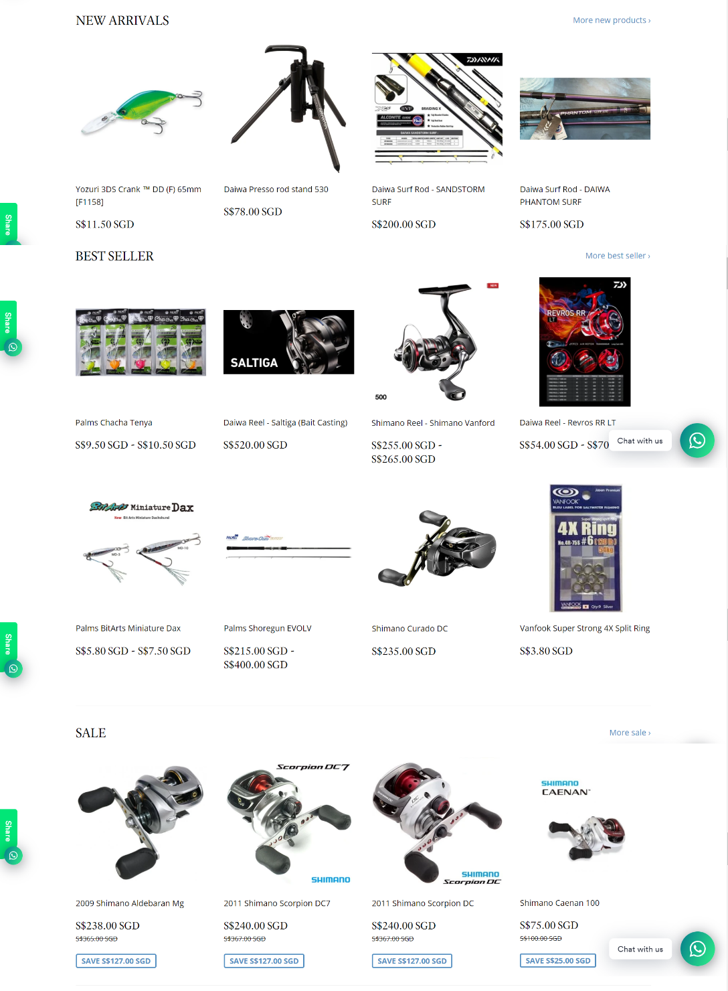

Current Website:

[www.fishingbuddy.com.sg](http://www.fishingbuddy.com.sg)

* Product item cards can be smaller to present more products in one glance.
* “Add to Cart” can be added to Product item cards for immediate purchase.

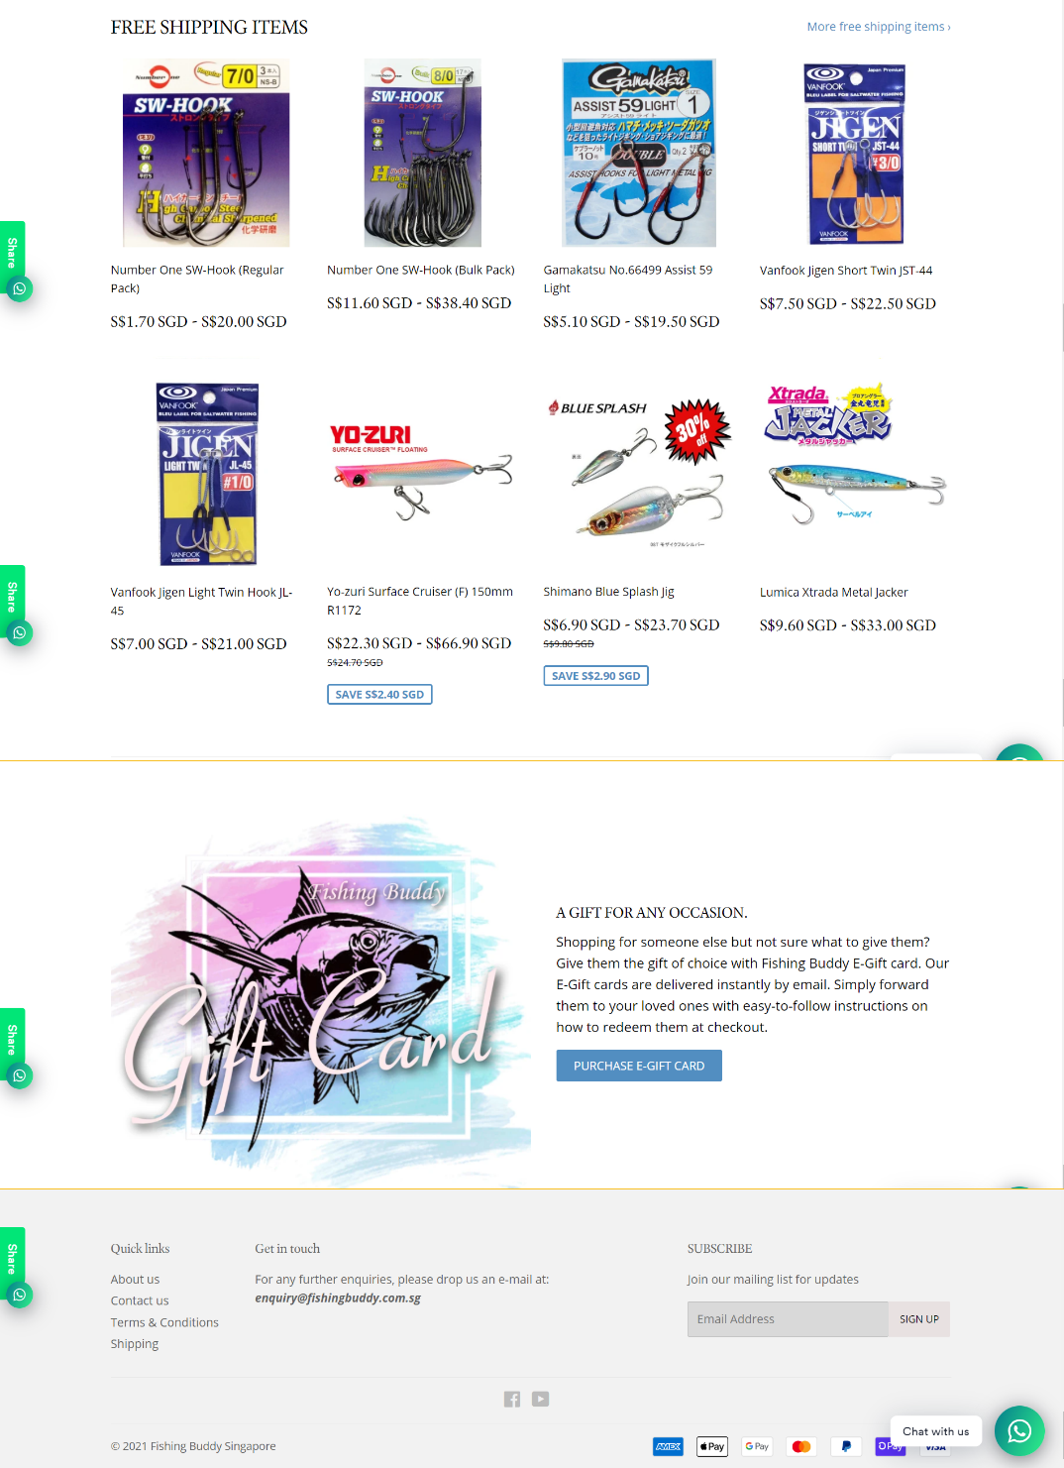

Current Website:

[www.fishingbuddy.com.sg](http://www.fishingbuddy.com.sg)

* To narrow down Footer section. However, after researching 20+ other e-commerce websites, all showed, having similar large footers. So retained expanded footer.

Existing Website: www.fishingBuddy.com.sg

* Call to Actions (CTA): Primary CTA. 

Secondary CTA. 

Text link. 

* Font Styles: Times New Roman 21pts. Shop For

# Cambria (Heading) 16 pts. **Daiwa Rod – Viper**

Calibri (Body) 18 pts. S$110.00 SGD

Arial 10pts. [Home](https://www.fishingbuddy.com.sg/)

Arial 10.5pts. Size

Arial (Bold) 10.5pts. **MODEL 60LS LENGTH 6’0″**

* Colour Palette: Black #000000, White #FFFFFF, Grey39 #636363.
* Carousell categories text, Segoe UI, 18pts: **Explore Carousell** 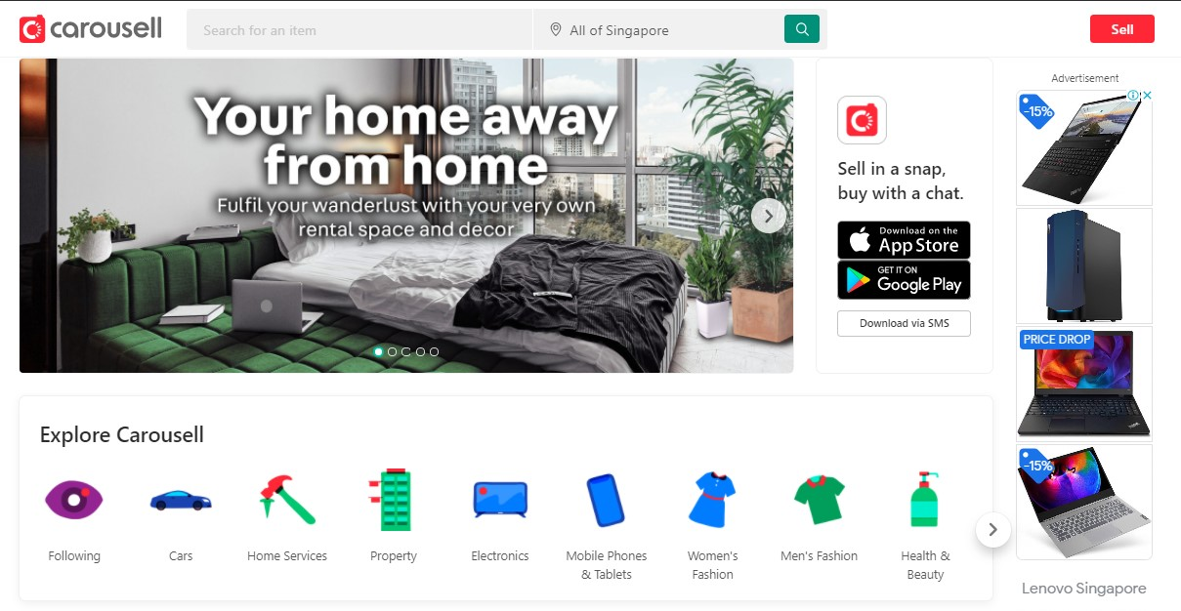
* Carousell categories text , Segoe UI, 10.5pts: Mitsubishi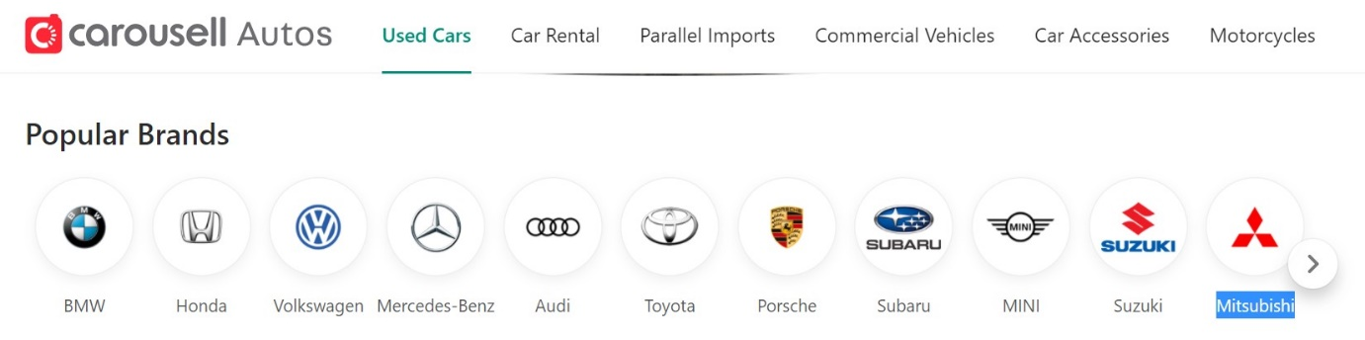
* Shopee category text, Helvetica 15pts, TOP PRODUCTS
* <https://shopee.sg/>

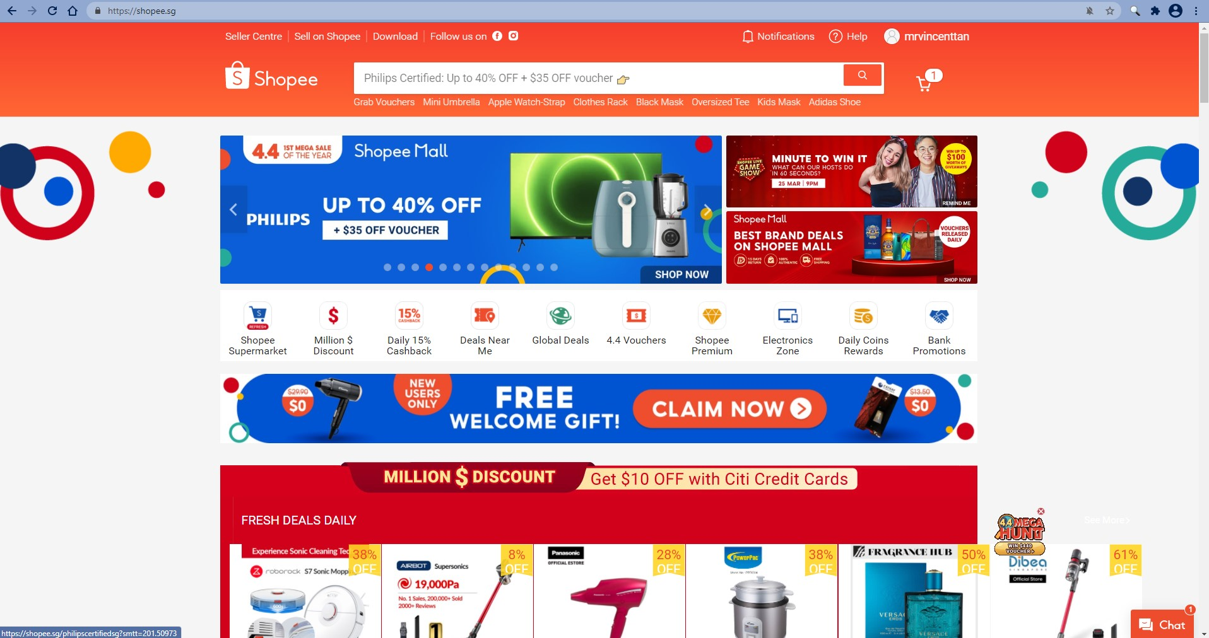

* <https://www.carousell.sg/> (Carousel “banner”, and “Explore Carousell” categories)



* <https://www.carousell.sg/> (Heart favourites icon) 
* <https://www.costco.com/grocery-household.html> (Covid pandemic note) 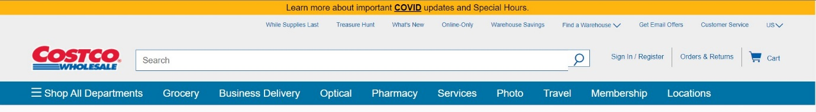
* <https://shopee.sg/> (cart counter) 
* <https://shopee.sg/> (Banner & colourful margins at LHS & RHS) 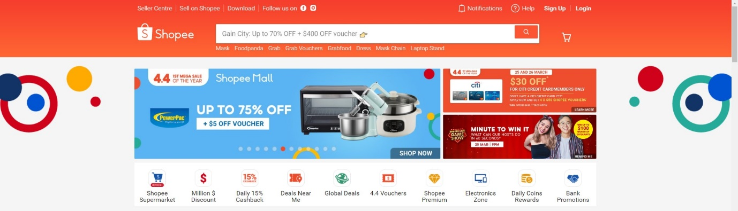
* <https://shopee.sg/> (categories) 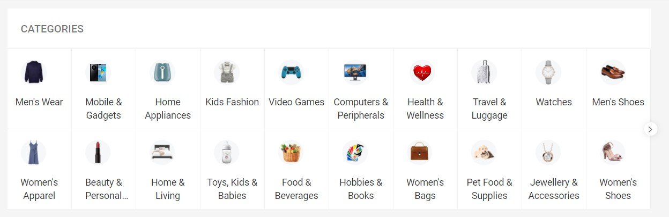
* <https://www.ebay.com/> (Sign in or register) 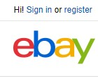
* <https://shopping.yahoo.com> (Content colour extend to side margins) 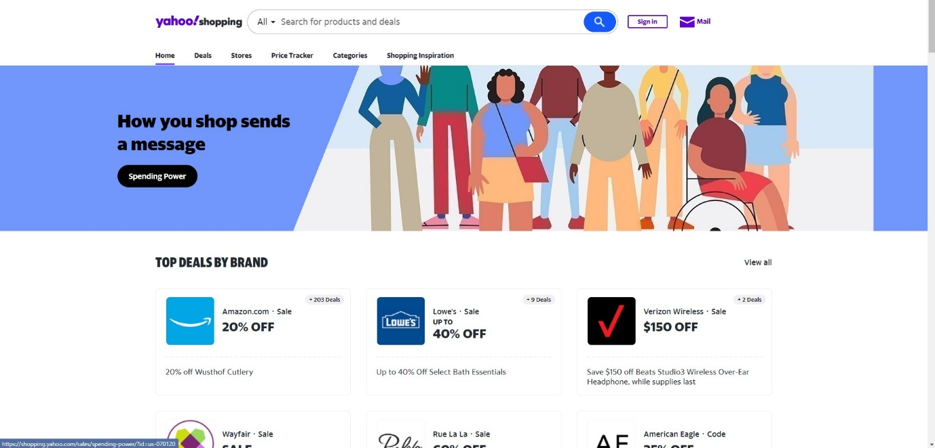
* <https://www.carousell.sg/cars/used-cars-for-sale/Mitsubishi/> (Product page)

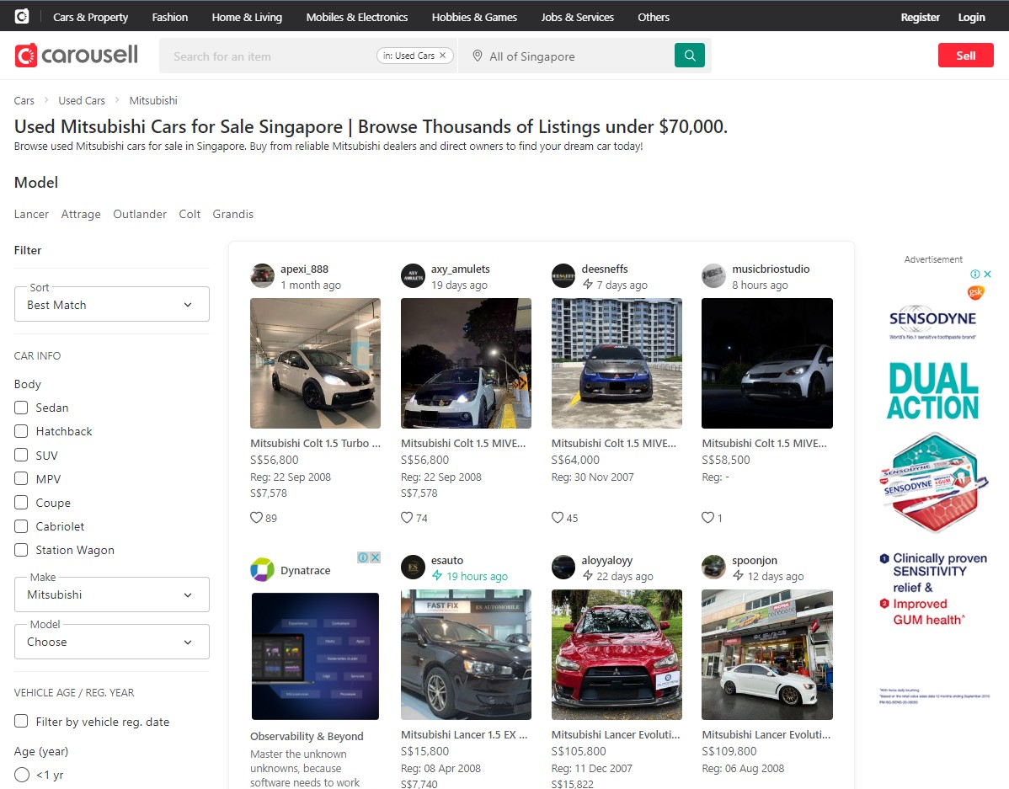

* <http://www.shopee.sg> (Product Item Page)

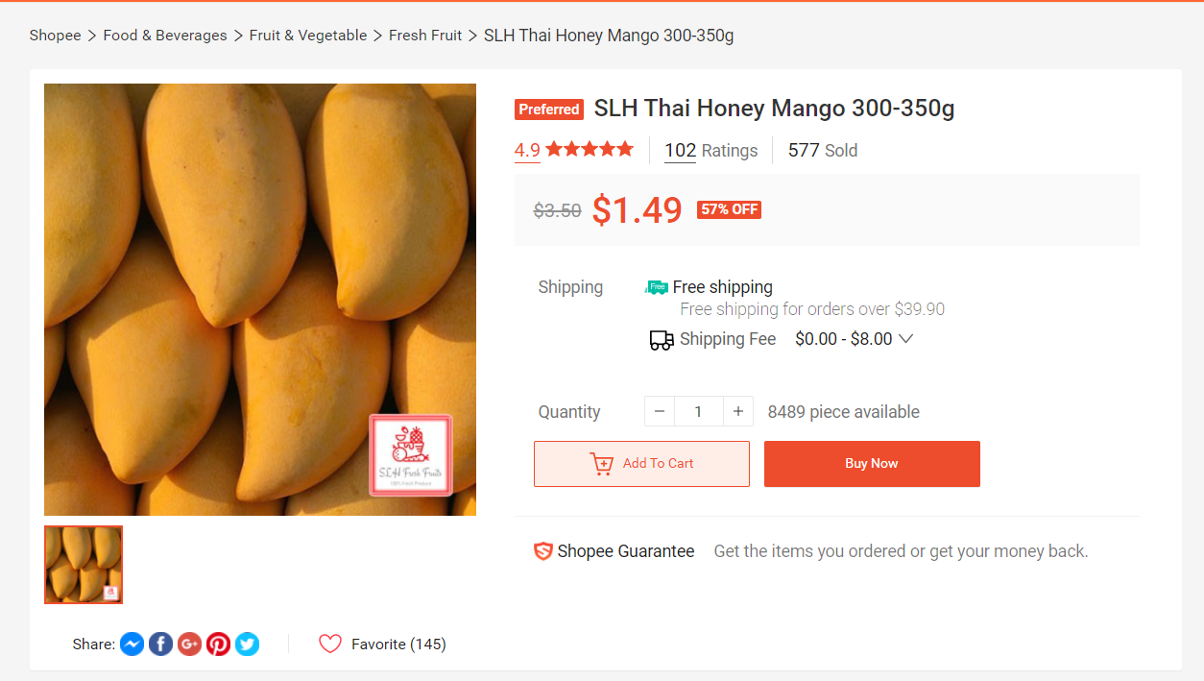

* <https://shopee.sg/cart> (Shopping cart page)

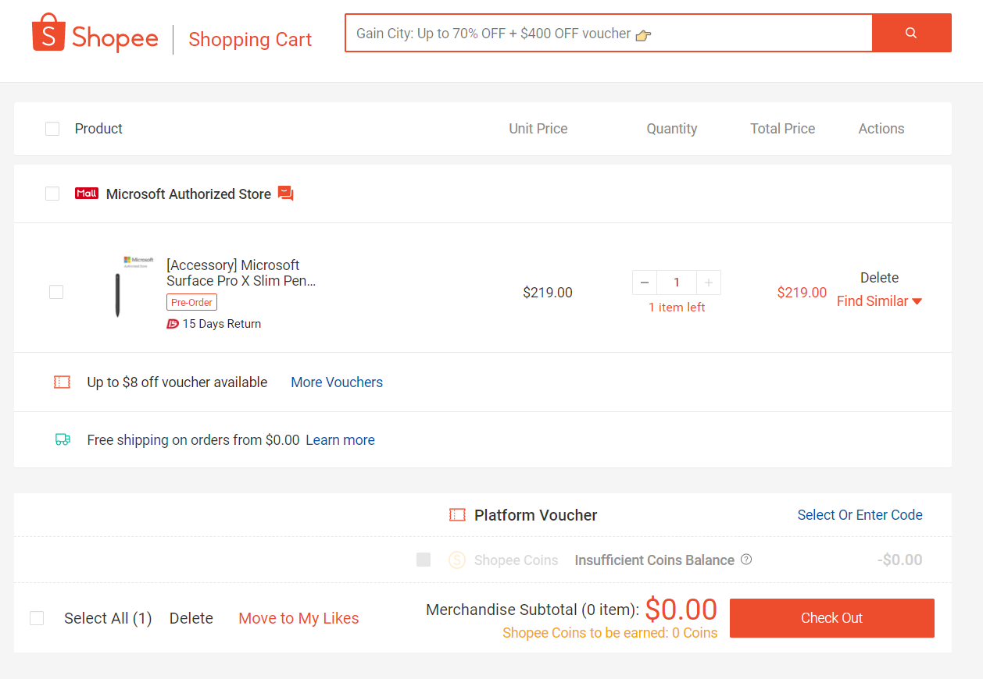

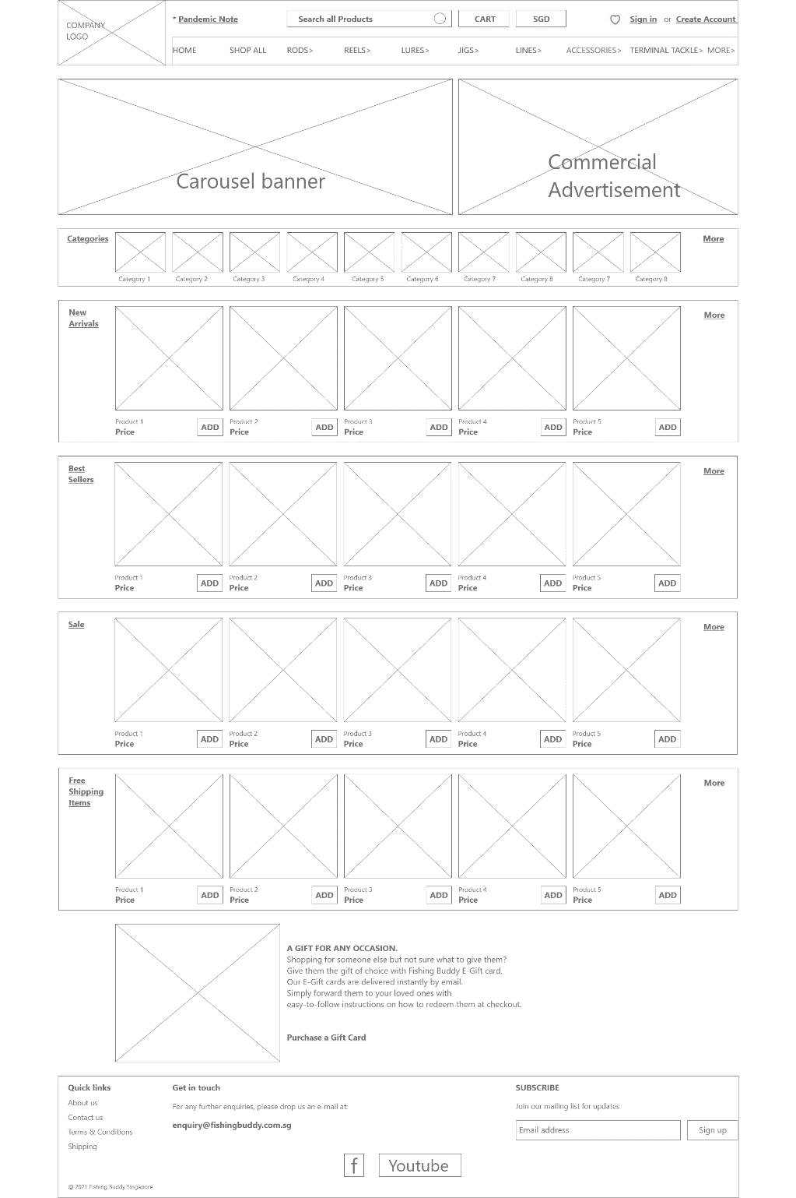

Home Page

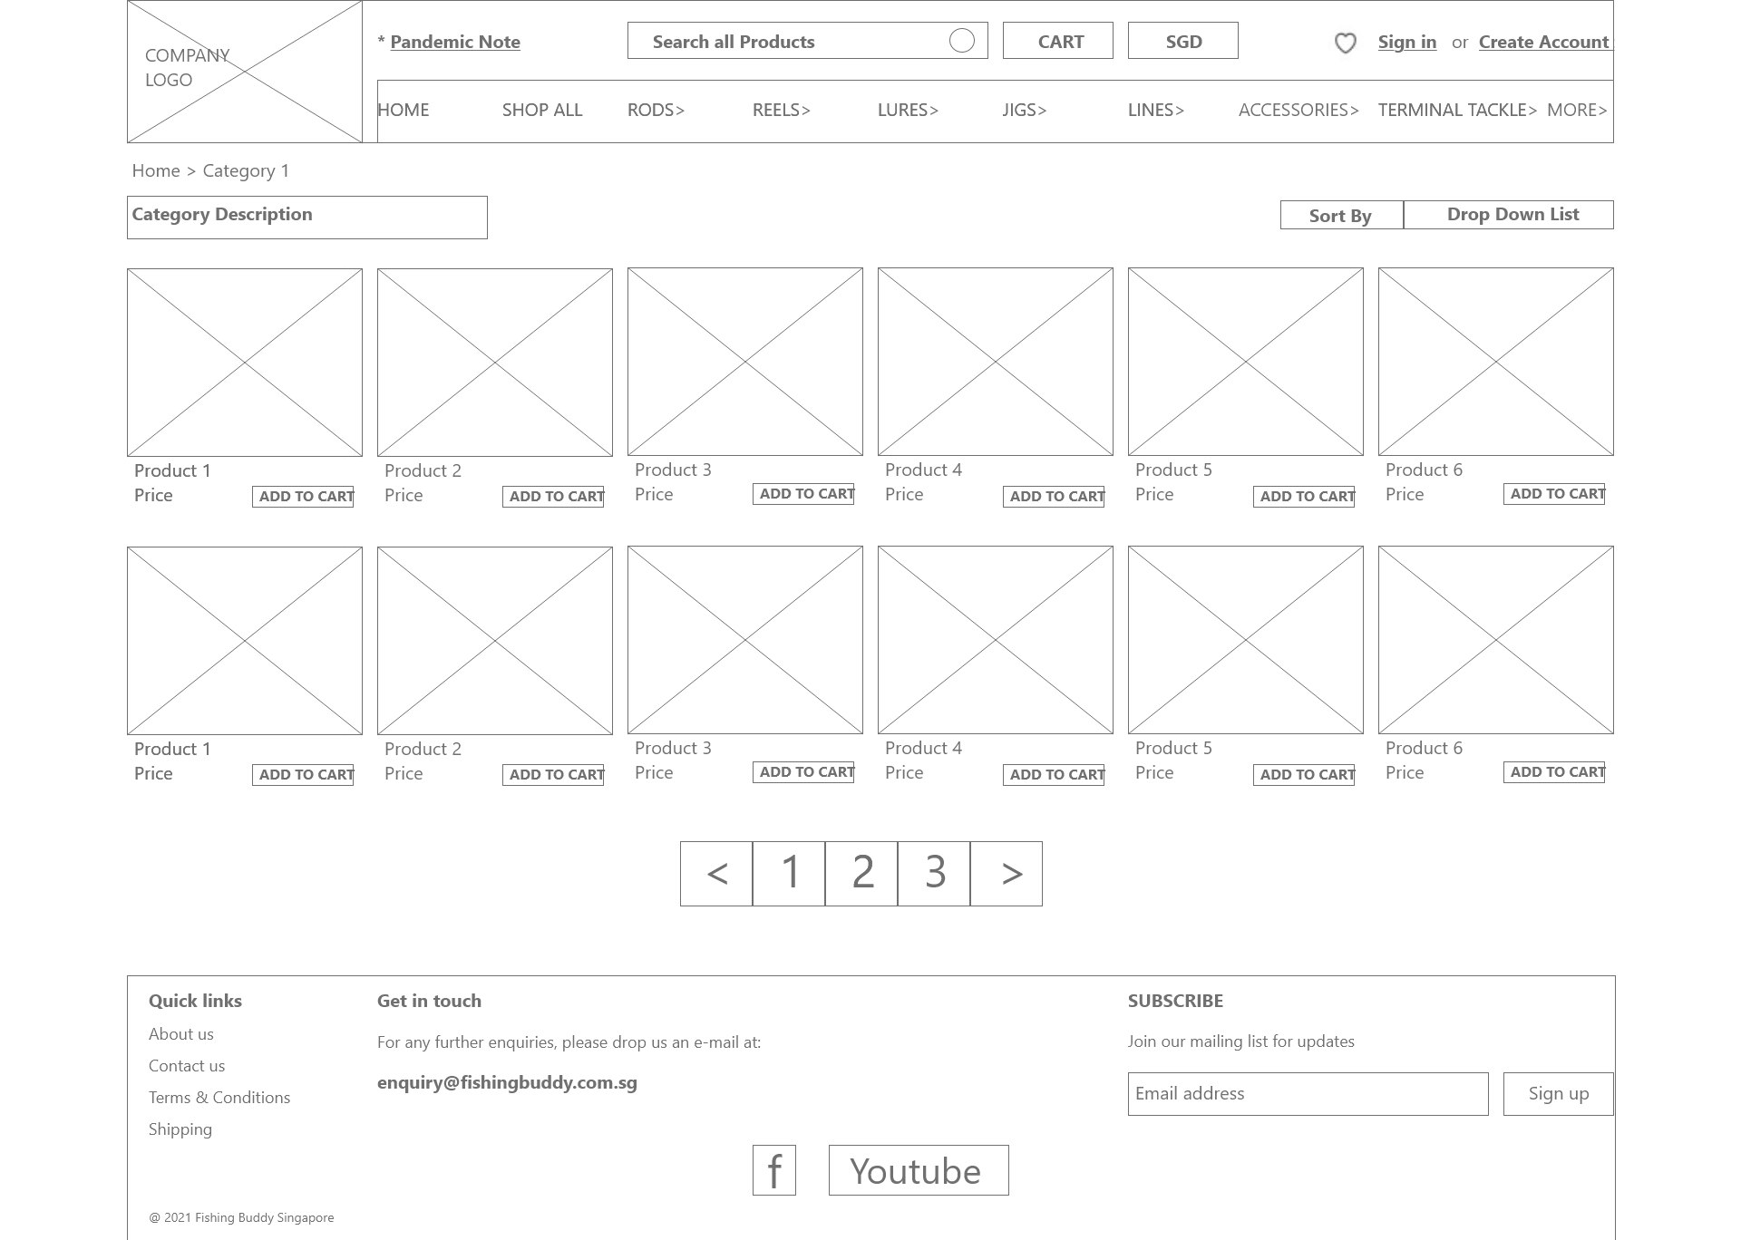

Category

Page

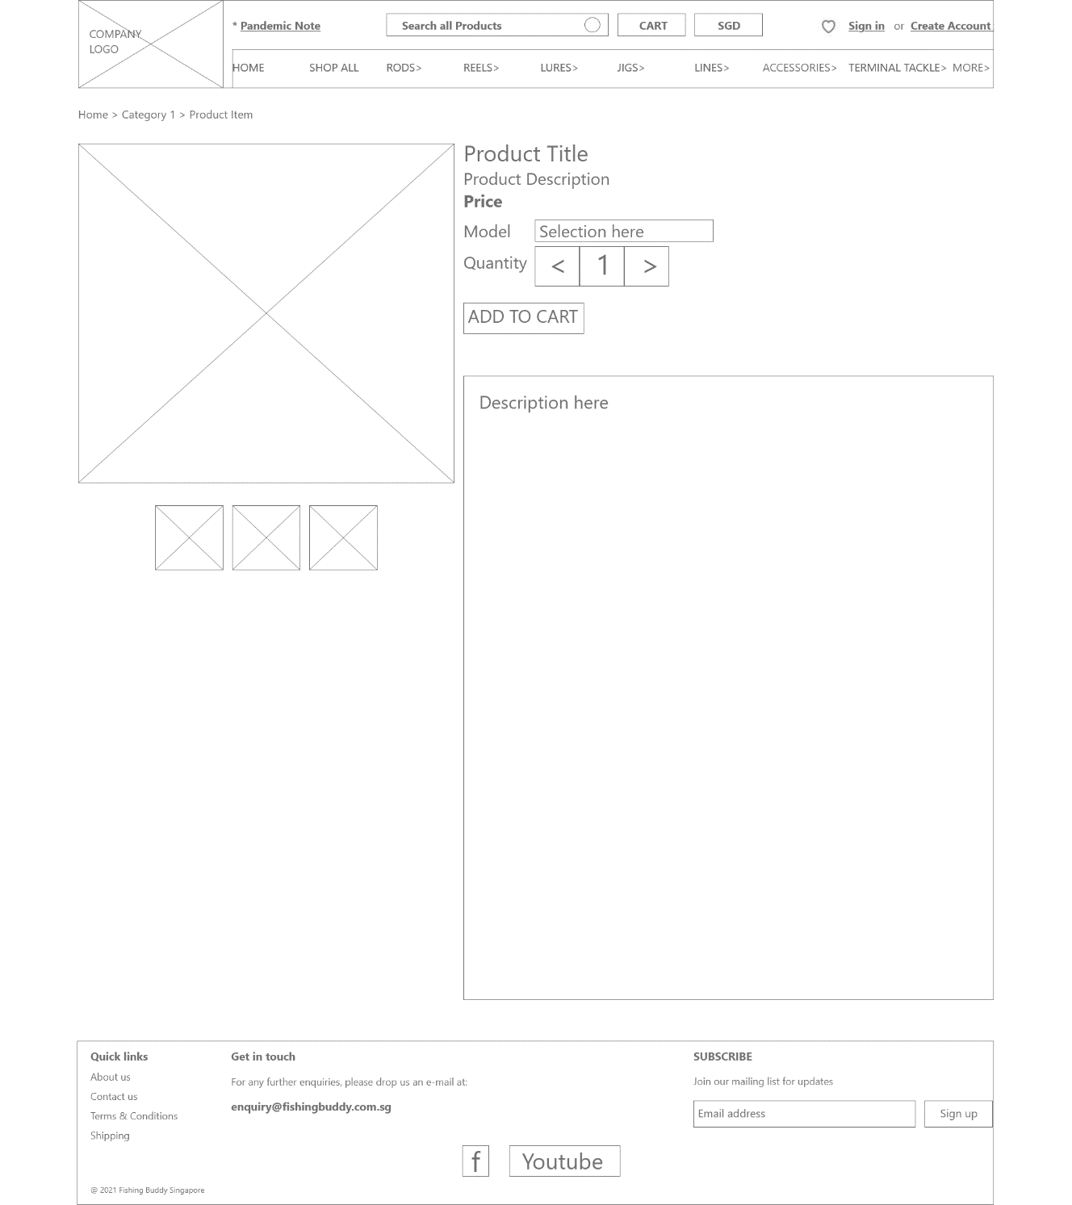

Product Item

Details Page

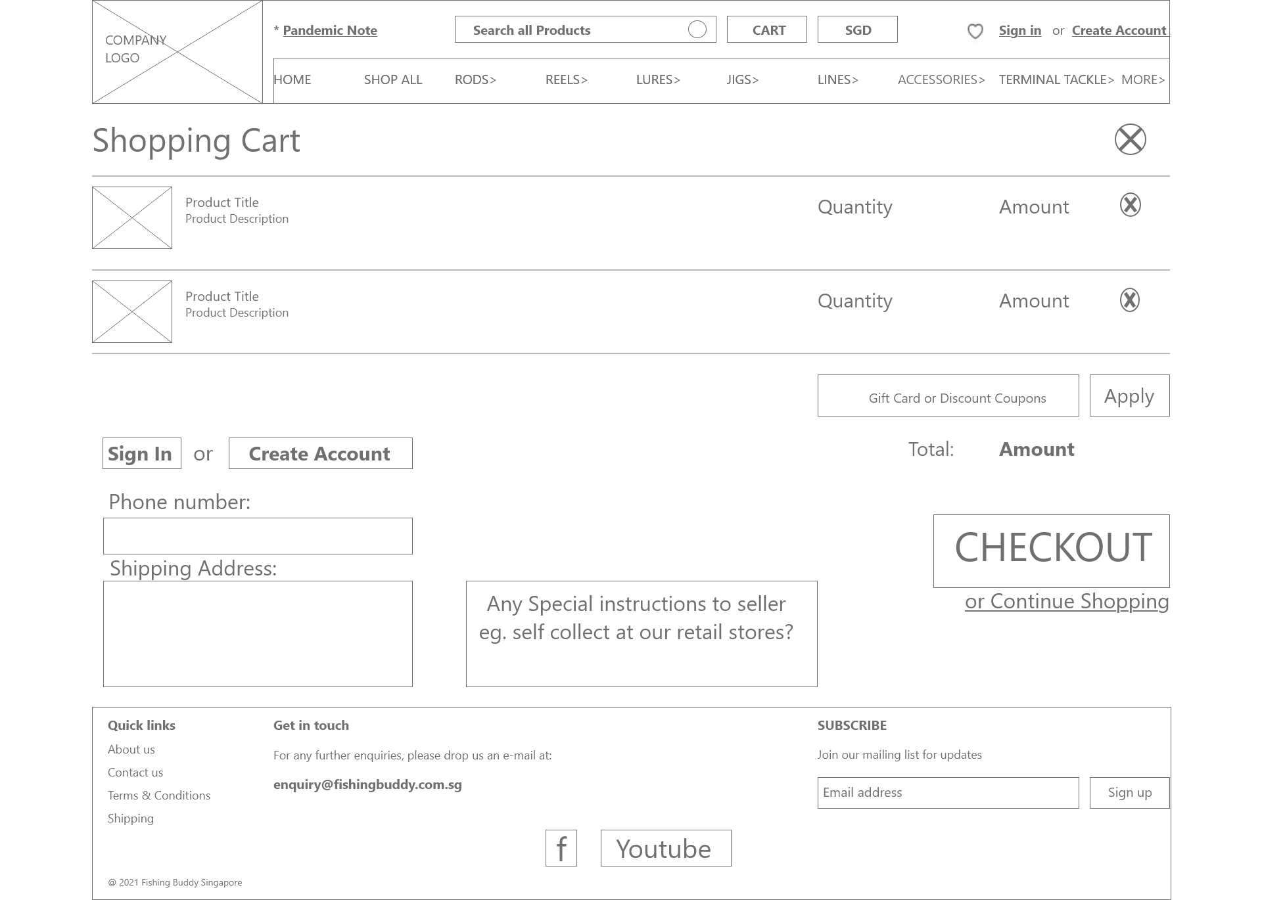

Shopping

Cart

Page

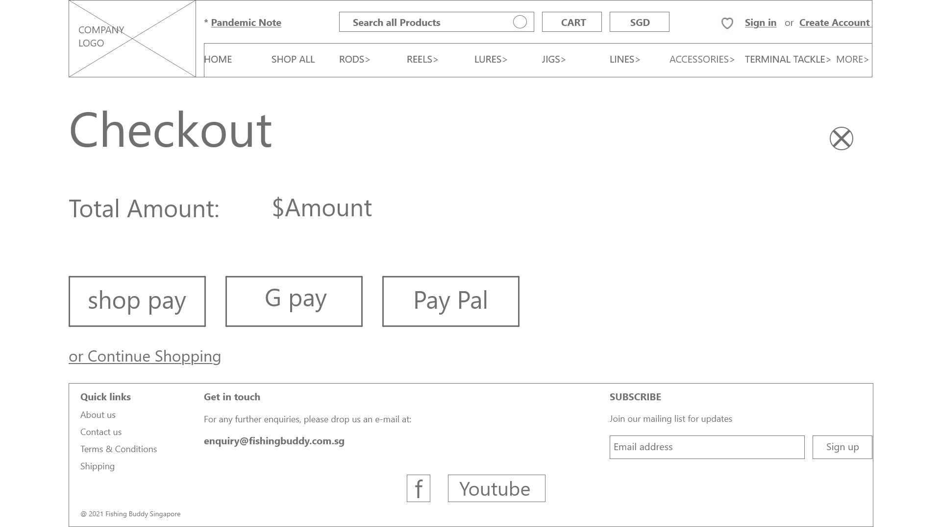

Checkout

page

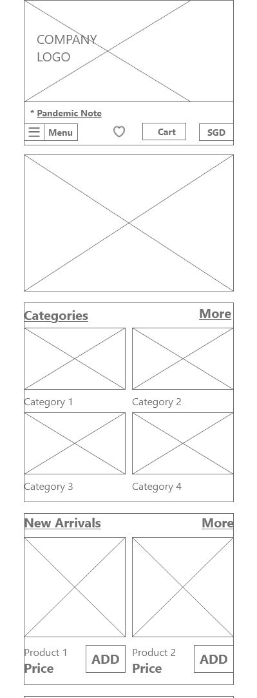 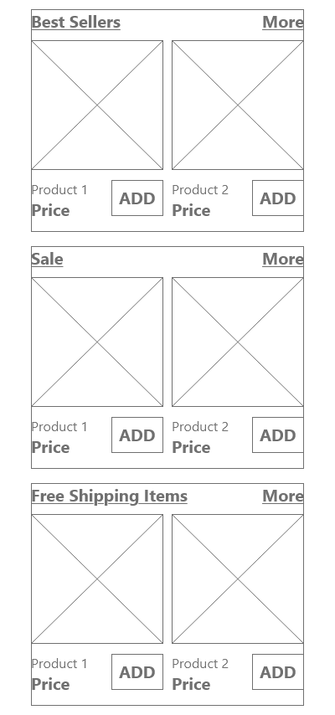 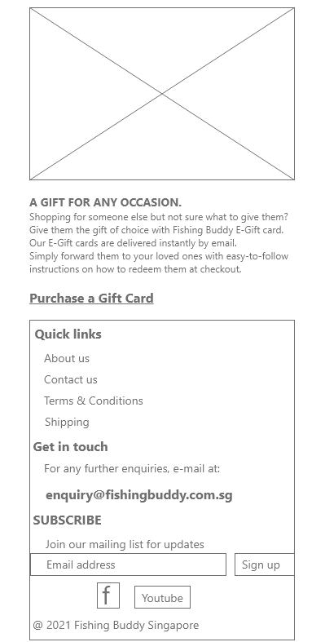

Mobile Home Page

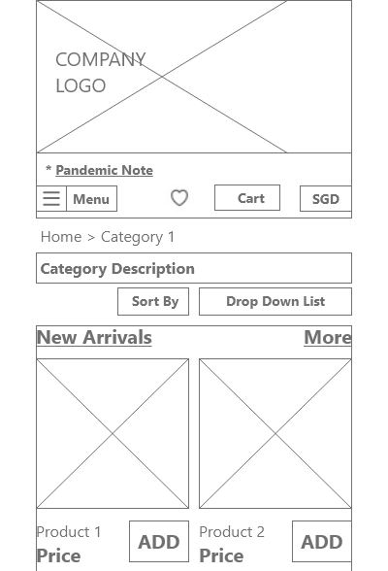 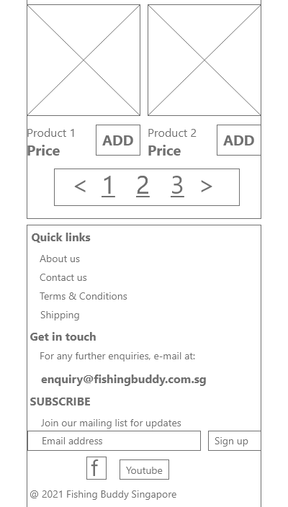

Mobile Category Page

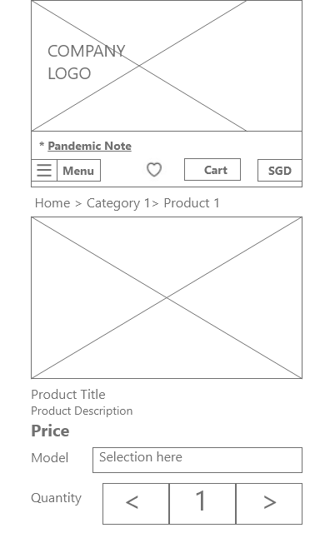 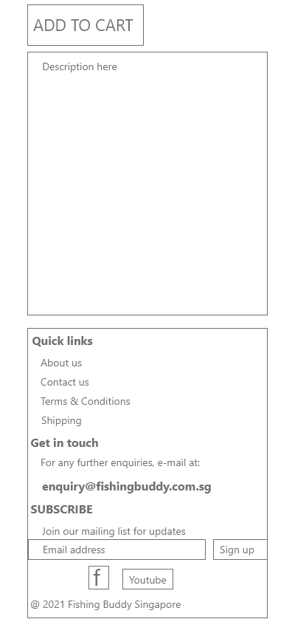

Mobile Product Details Page

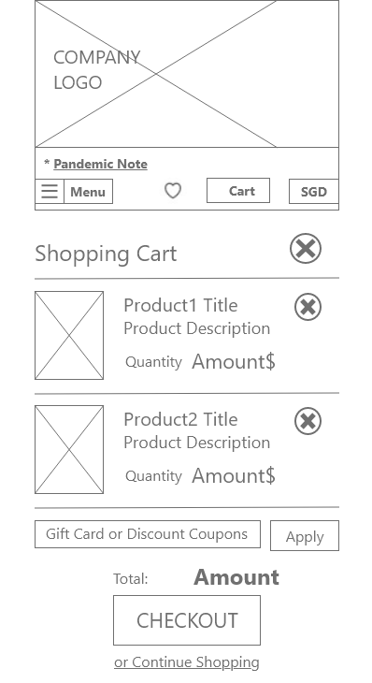 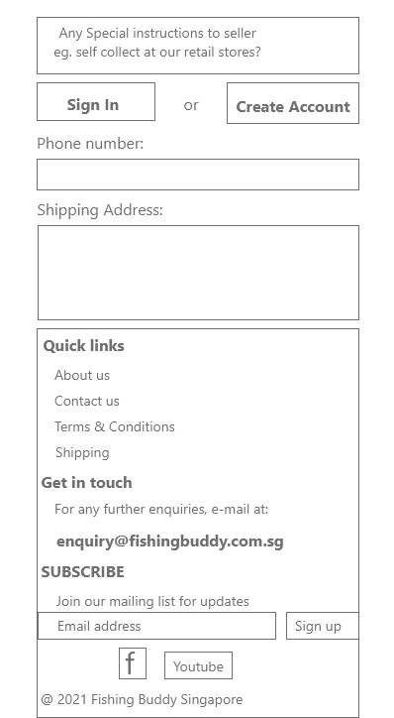

Mobile Add To Cart Page

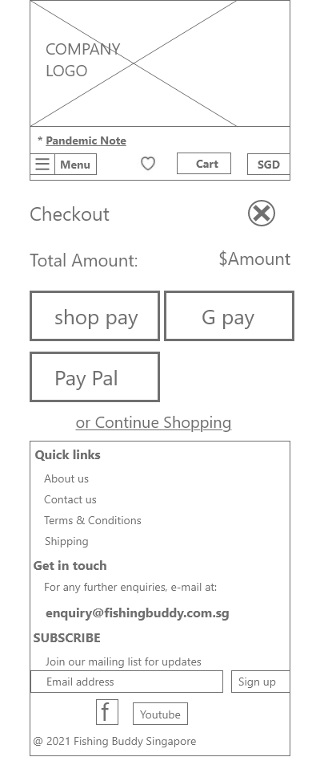

Mobile Checkout Page

UI Revamp:

* Narrowed header so can use more precious content space for promoting products;
  + Hid Google tracking text from user.
  + Hid pandemic delivery note into link text.
  + Sticky header with Navigation bar remains at the top of every page.
* Reduced carousel banner to half viewport;
  + previously some banners exceeded viewport page.
  + Added commercial advertisement banner beside carousel banner.
* Differentiated category row from products row.
  + Category row shows 10 cards, without pricing.
  + Products rows show 5 cards, with pricing & convenient [Add-to-cart] button.
* Grouped all gathering of user information to Shopping cart page;
  + Checkout page is now simply a payment page.
* Maintained consistent 5 product cards per row for each category shown, in entire Home page.

Proposed new functionalities:

* [Add to cart] buttons included with every product card pictures.
* Added convenient [favourites] bookmark for users.
* Removed [Pay now] button in product items details page.
  + So that user is guided on the consistent flow of Add-to-cart 1st, before checkout then can make payments.

Font Style:

* Seguo UI sans serif font applied to entire web site.
* Bold for **Categories title, Price $**, **Product item details price.**
* Hyperlink text – underlined.
* Regular for all the rest.

Call-To-Action buttons:



Colour Palette:

Black #000000, White #FFFFFF, Grey #DDDDDD,  Blue #528EC1

User

1. Lands on Home Page
2. Selects Category
3. Selects Product Item
4. Selects Details Page of this Product
5. Reviews Details of Product
6. Selects [Add-To-Cart] button
7. Reviews Selected Products in Shopping Cart Page
8. Selects [Checkout] button
9. Selects [Payment] mode
10. Completes online payment.

Desktop Prototype website User usage flow:

Homepage

> Category Page

> Product Details Page

> Cart Page

> Checkout Page.

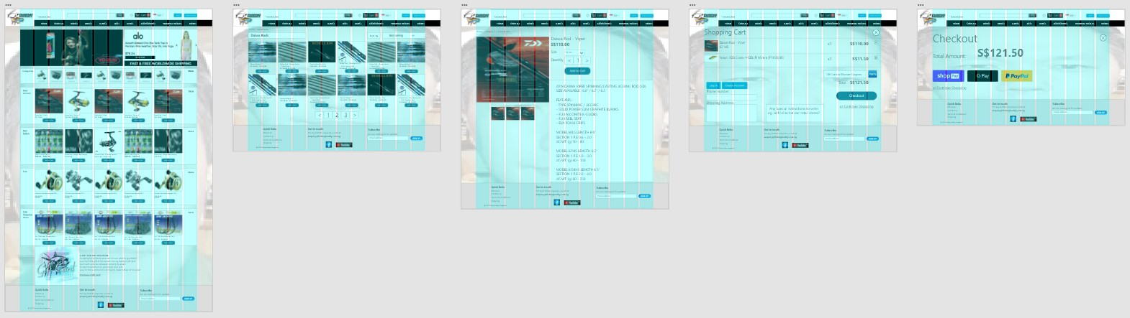

Checkout Page

Shopping Cart Page

Product Details Page

Category Page

Home Page

**PROTOTYPE**

Illustrating the overall prototype links:

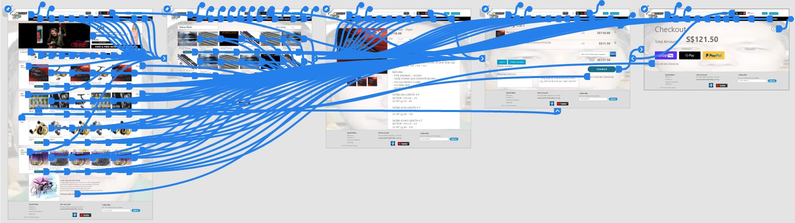

Product Details Page

Category Page

Home Page

Checkout Page

Shopping Cart Page

**PROTOTYPE**

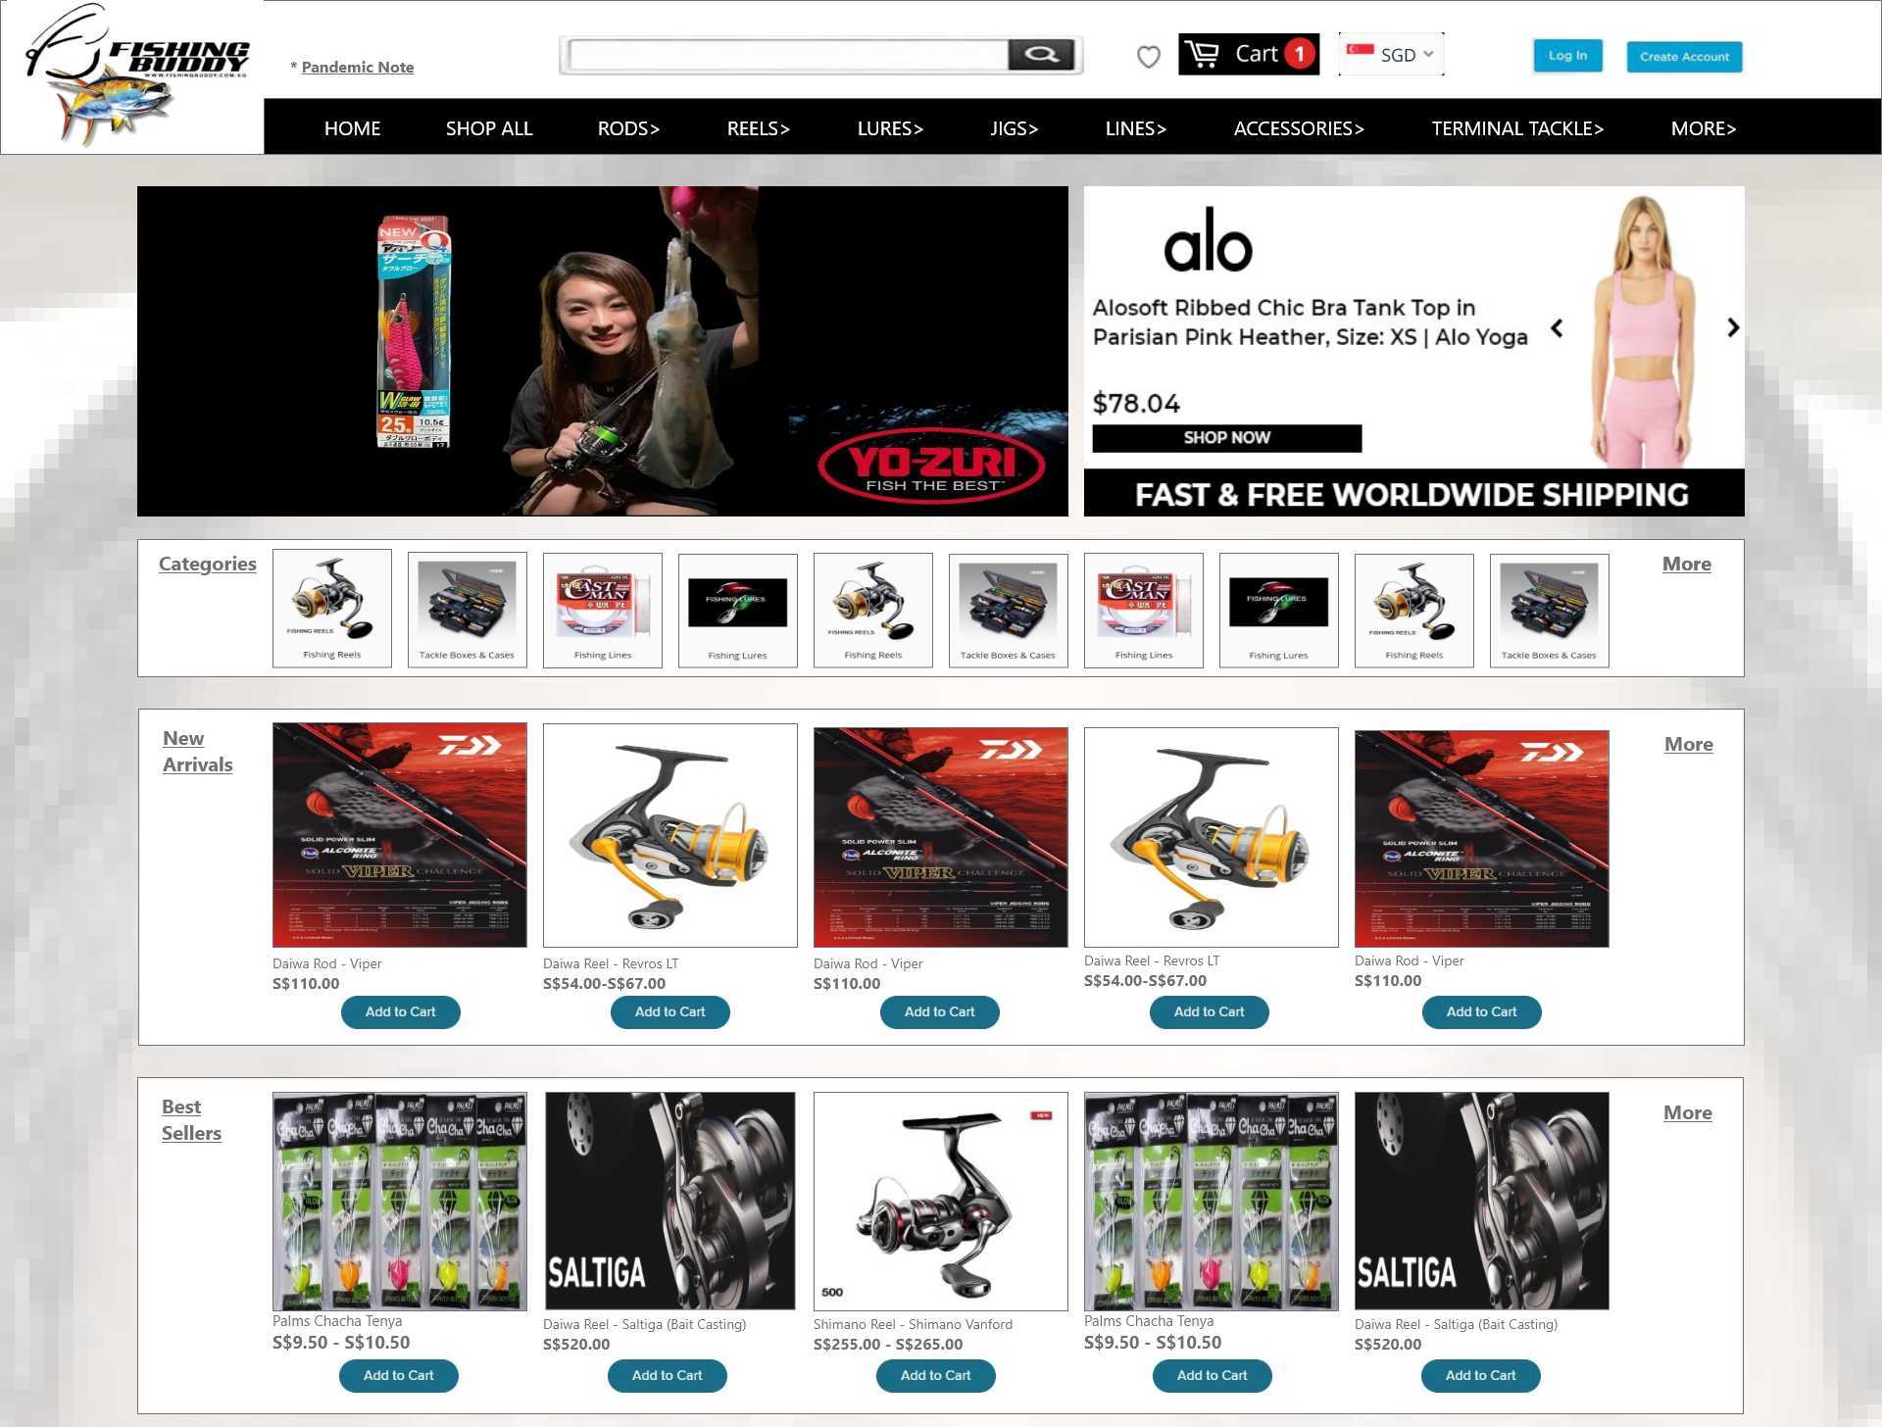 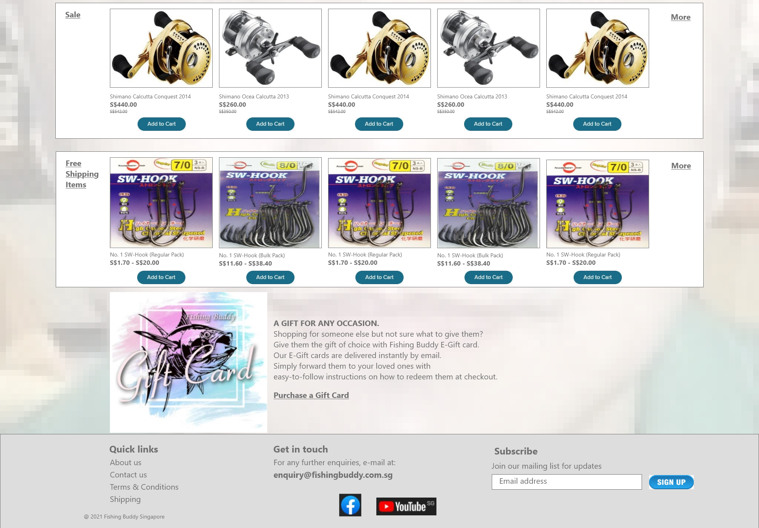

Desktop Prototype Home Page

Desktop Prototype Home Page

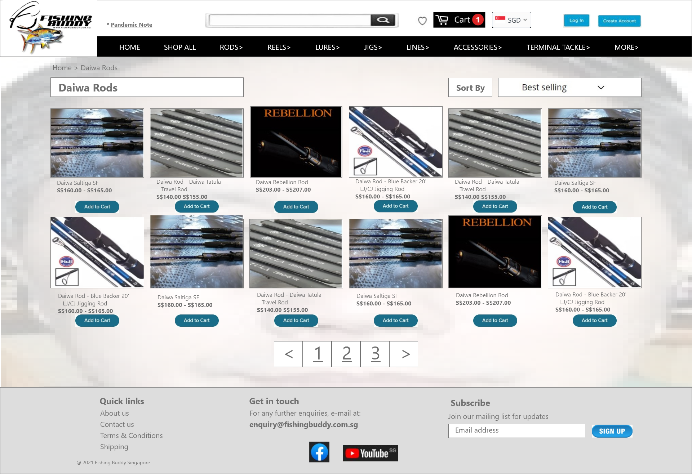

Desktop Prototype Products Category Page

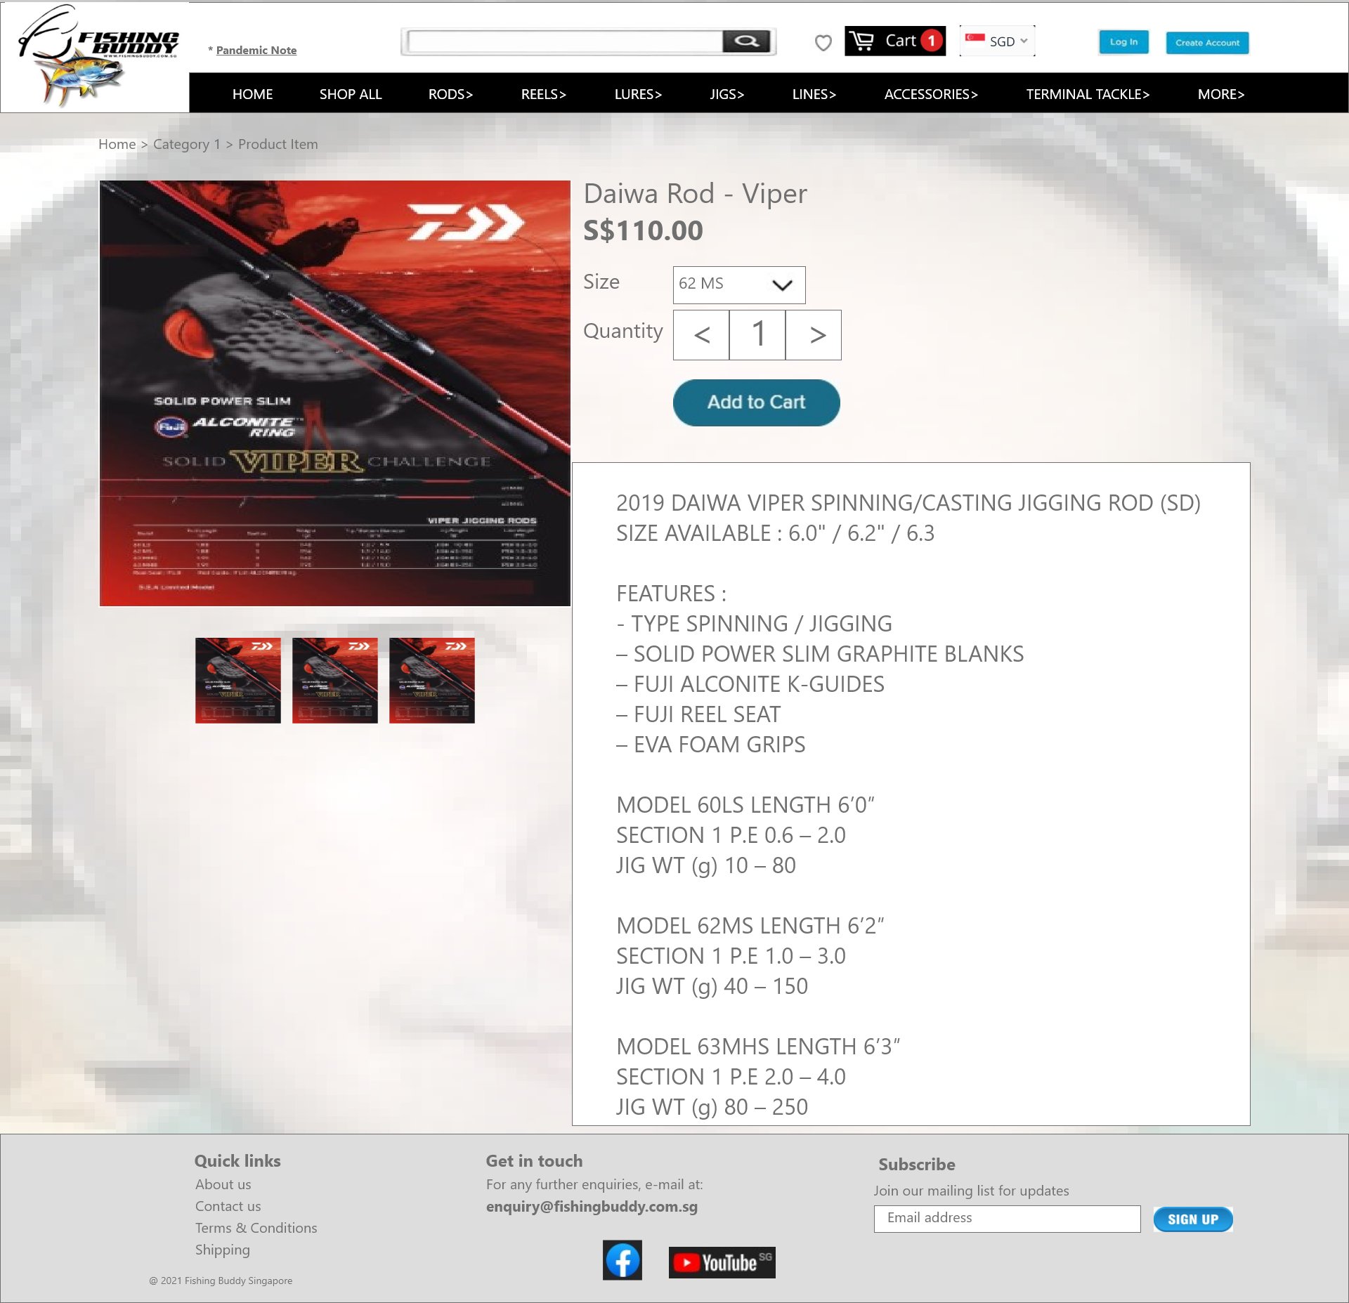

Desktop Prototype Product Details Page

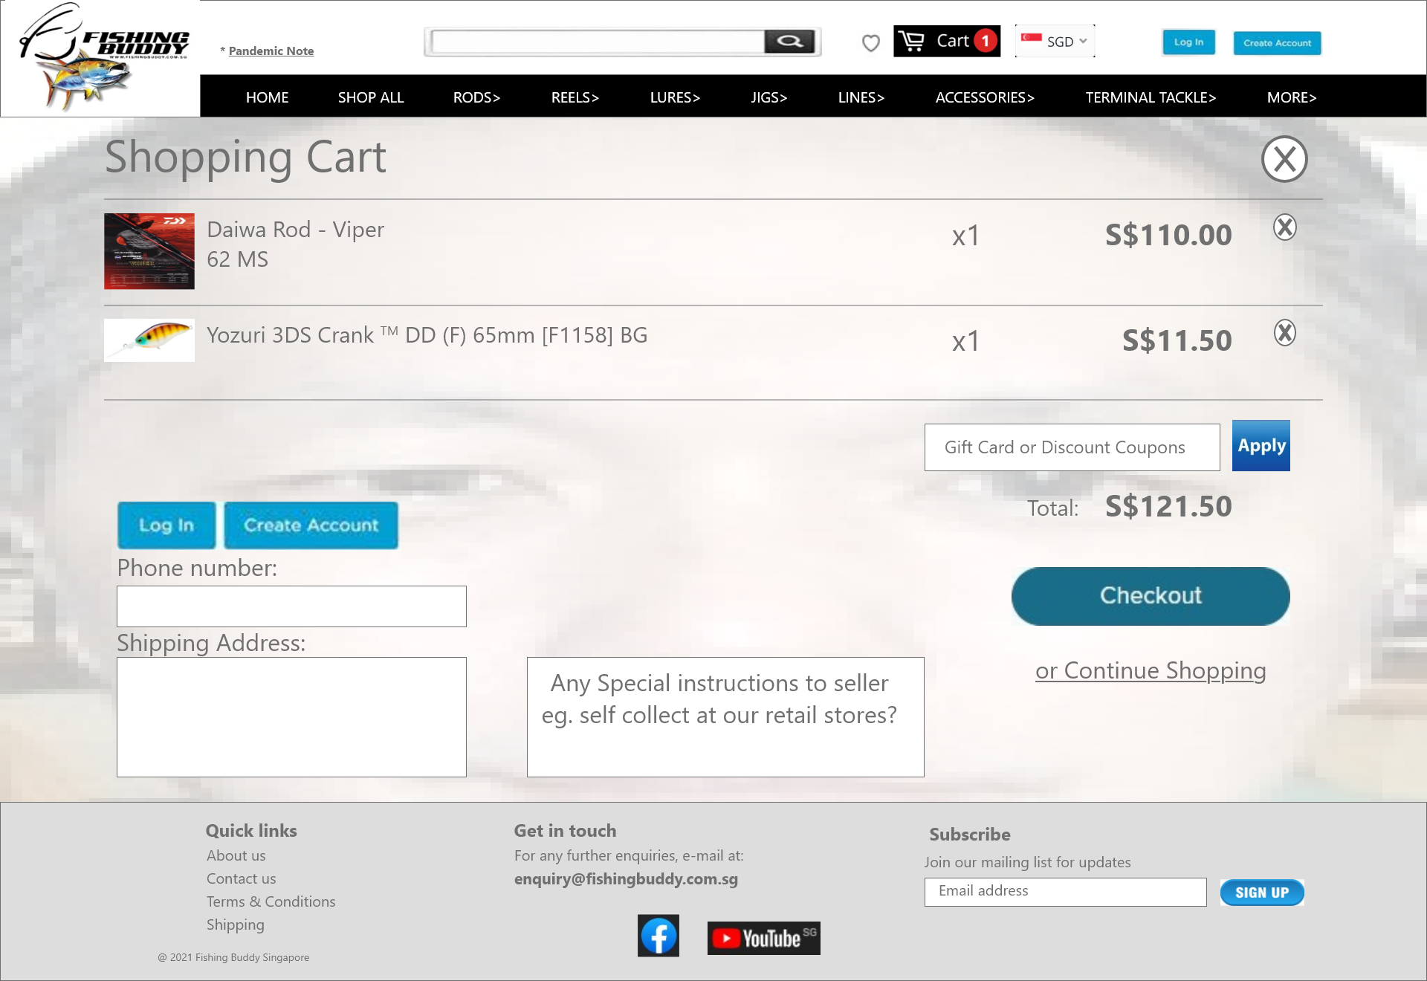

Desktop Prototype Shopping Cart Page

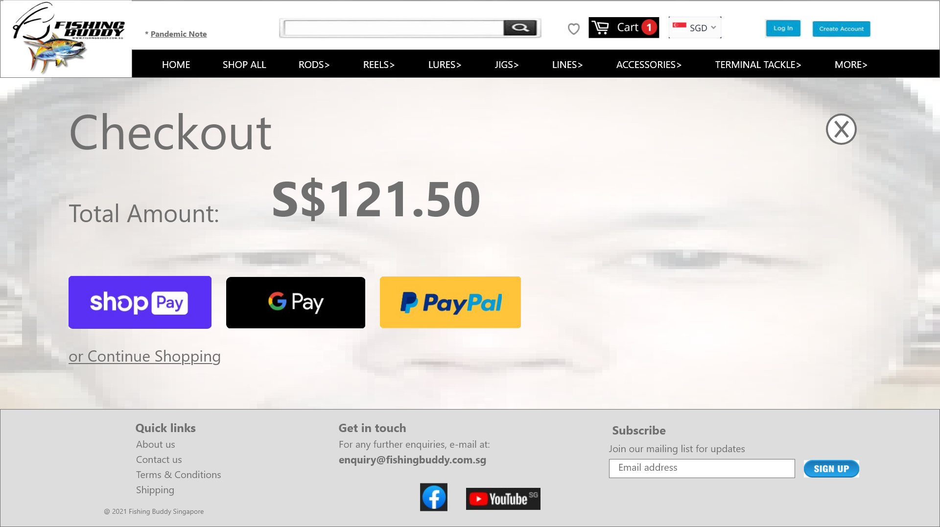

Desktop Prototype Checkout Page

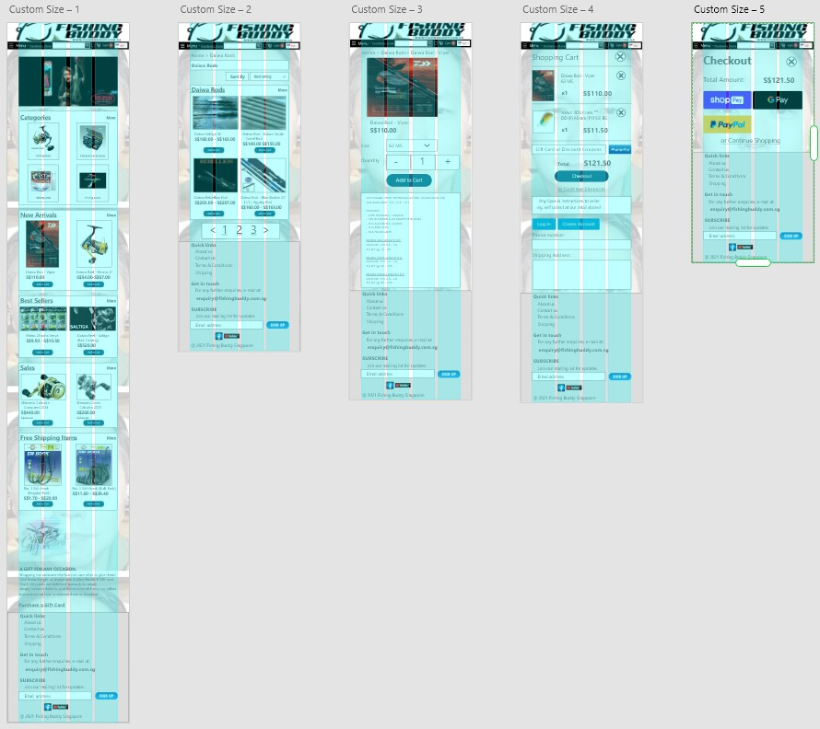

Checkout Page

Home Page

Category Page

Product Details Page

Shopping Cart Page

Mobile Prototype website User usage flow:

Homepage

> Category Page

> Product Details Page

> Cart Page

> Checkout Page.

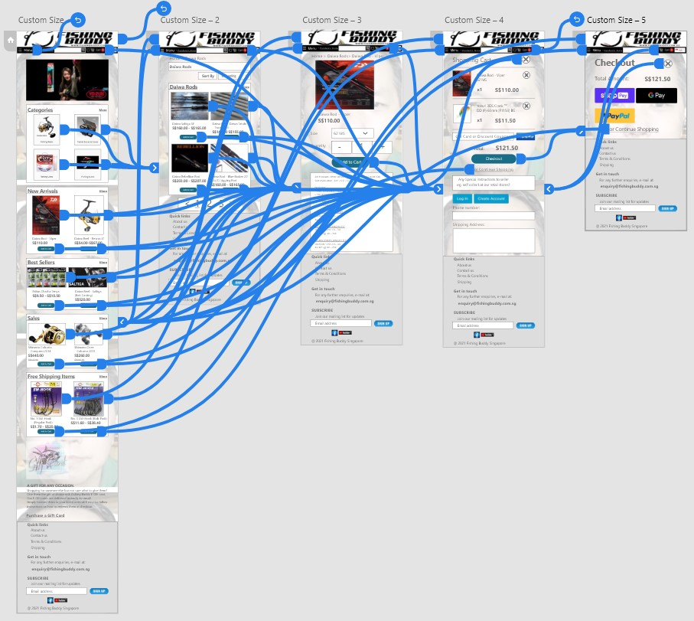

Mobile Prototype website:

Illustrating the overall prototype links.

Home Page

Category Page

Product Details Page

Shopping Cart Page

Checkout Page

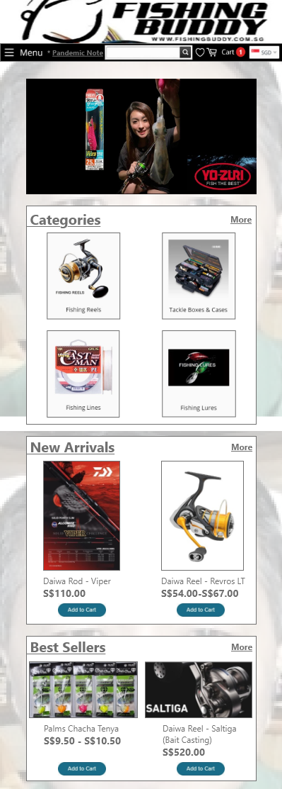 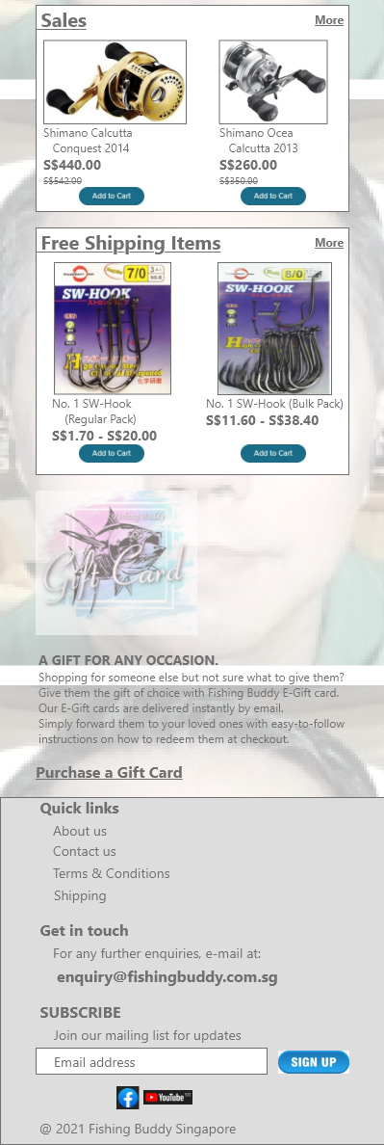

Mobile Prototype Home Page

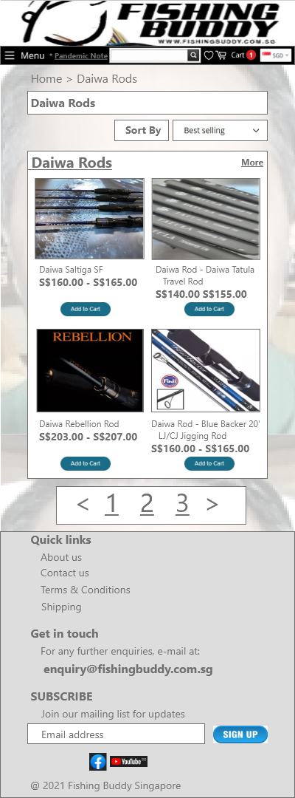 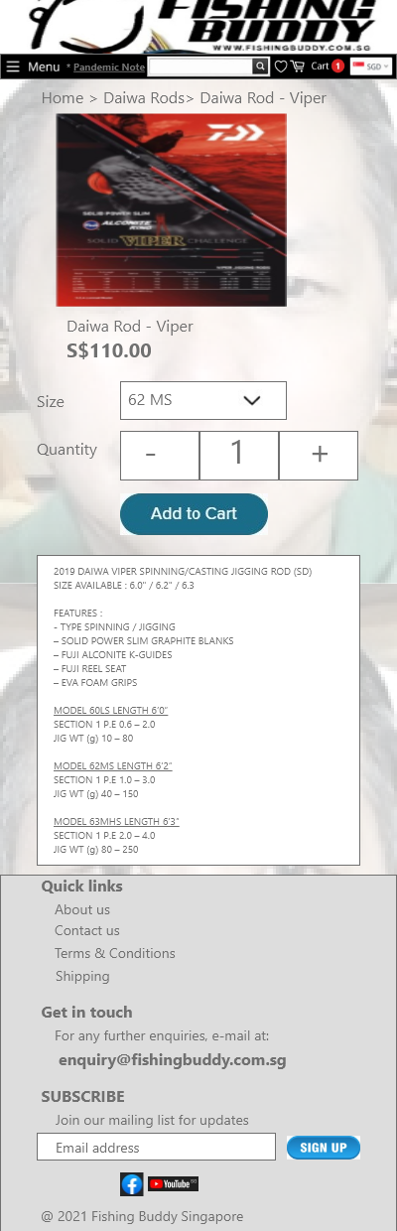

Mobile Prototype Category Page

Mobile Prototype Product Details Page

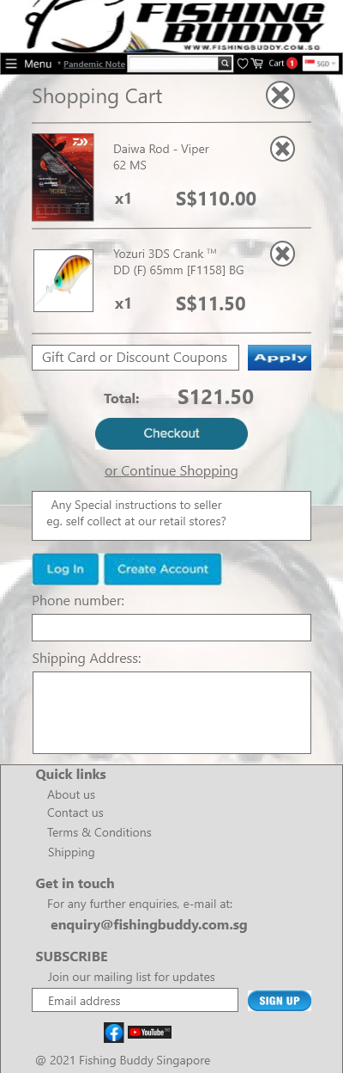 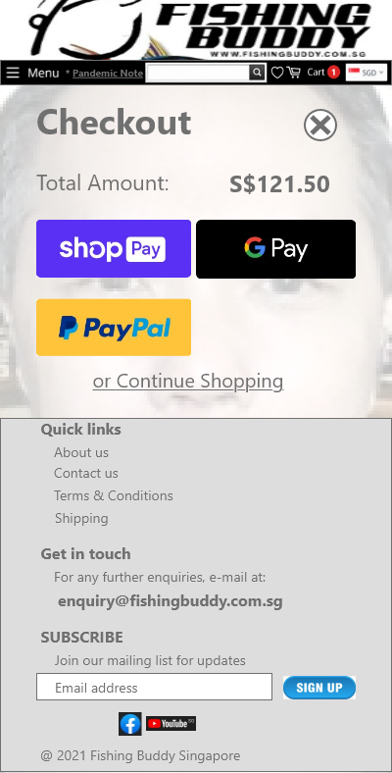

Mobile Prototype Checkout Page

Mobile Prototype Shopping Cart Page

Components of the website:

**BUTTONS:**

   

    

**ICONS:**

     

**FORM FIELDS:**

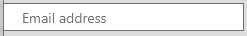 

 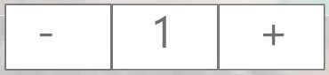 

 

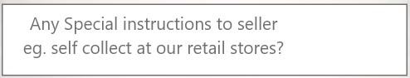

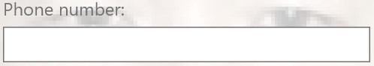

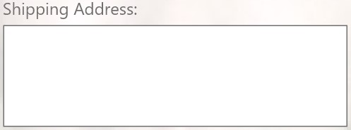

The End



**USER INTERFACE**

**DESIGN & DEVELOPMENTS**

**What The Fish**

www.fishingbuddy.com.sg